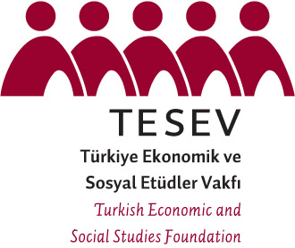
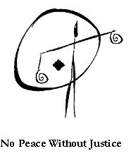


Forum for the Future: Civil Society Planning Meeting Program

May 10 2008, Istanbul Kultur University

09.30 Meeting at the lobby (Richmond Hotel)
10.00 – 10.30 Registration

10.30 – 11.15 First Session: G8-BMENA initiatives: Assesment and Lessons Learned
Moderator: Lamis Nasser – Women’s Forum for Human Rights (TBC)
Speakers: Gianluca Eramo - NPWJ
Yousuf Aburas - HRITC
Sanem Güner - TESEV

11.15 – 12.30 Open Discussion

12.30 – 14.00 Lunch

14.00 – 14.45 Second Session: Civil Society’s Priorities for the 2008 Forum for the Future
Moderator: Mensur Akgün
Speakers: Hoda Chalak (TBC)
Saad Eddin Ibrahim
Mohsen Marzouk - Arab Democracy Foundation

14.45 – 15.30 Open Discussion

15.30 – 16.00 Coffee Break

16.00 – 17.45 Third Session: The Way Forward
Moderator: Ebtisam Al Kitbi
Speakers: Open Discussion

17.45 – 18.00 Concluding Remarks

Mensur Akgün – TESEV

18.00 Bus departs Kultur University campus to go to dinner (Participants who have flights in the evening depart for the airport)

19.00 – 21.30 Dinner

