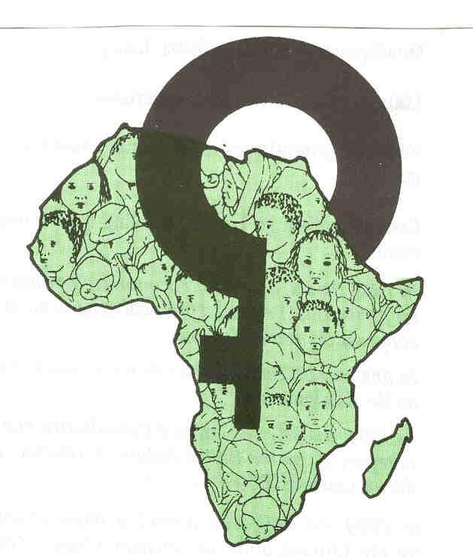Inter-African Committee on Traditional Practices
Affecting the Health of Women and Children (IAC)

7th General Assembly/International Conference

Program

Date: Tuesday October 27 to Friday 30, 2008

Venue: Cairo, EGYPT

First Day: Monday October 27 2008

8:30 – 9:30 - Registration
9:30 – 11:00 - Opening Ceremony
- Group Photograph

11:00 – 11:30 Coffee Break

11:30 – 12:00 - Election of Conference officers
- Adoption of the Agenda

- Report by the IAC Executive Director,
Berhane Ras-Work (3 years Activity report)

12:00 – 13:00 - Comments, discussion adoption of the report

13:00 – 14:00 Lunch Break

14:00 – 16:00 Reports: from IAC HQ, Addis Ababa:

- Dr. Morissanda KOUYATE

- Mrs. Linda Osarenren
- Mrs. Diariatou Kouroma
- Mrs. Abebech Alemneh

- Comments and observations on reports - Adoption

16:00 – 16:30 Financial Report By:
- IAC Treasurer
- Getachew Benalfew Co & Accountants (External Auditor)

- Comments, Observations, Adoption of report

16:30 – 17:00 Presentation of Dutch Government Summary Evaluation report of IAC by:
Mrs Marianne Nugteren
EOC Consult, Netherlands

17:00-17:30 IAC Structure & promotion of Sustainability by:
- Mr. Alemayehu Assefa Tessema
Head, Consultancy & Research, African Institute of Management Development and Governance (AIMDG)
- Comments and observations

Second Day: Tuesday October 28, 2008

09:00 – 11:00 Activity Reports: National Committees
(Benin, Burkina Faso, Cameroon, Central African Republic, Congo, Cote d’Ivoire, Djibouti, Egypt, Ethiopia, Gambia, Ghana, Guinea Conakry)

11:00 – 11:30 Coffee Break

11:30 – 13:00 Activity Reports: National Committees Continues
(Guinea Bissau, Kenya, Liberia, Mali, Mauritania, Niger,
Nigeria, Senegal,)

13:00 – 14:00 Lunch Break

14:00 – 15:00 Activity Reports: National Committees Continues
(Sierra Leone, Somaliland, Sudan, Tanzania, Tchad, Togo, Uganda)

15:00 – 17:30 Activity Reports: IAC Group Sections/Affiliates

- Austria
- Australia
- Belgium
- Canada
- Denmark
- France
- Great Britain
- Italy
- Japan
- Netherlands
- New Zealand
- Spain
- Sweden
- USA

17:30-1800 Discussions

Third Day: Wednesday October 29, 2008

9:00-10:00 Panel Discussion: Partnering with the Media to reach Zero Tolerance to FGM (Nigeria, Senegal, Sudan, Ethiopia (IAC Scientific Committee)
Moderator: Egypt

10:00-11:00 Panel Discussion: Effective Involvement of Youth in the elimination of HTPs (Ghana, Niger, Sierra Leone, Tanzania)
Moderator: Norway

11:00 – 11:30 Coffee Break

11:30 – 12:30 Panel discussion: Practical steps to involve Religious and Political Leaders in HTP elimination (Two Religious from Egypt, 1 IPU representative, Mme. Mariam Lamizana)
Moderator: Dr. Amna A.R. Hassan, Vice President of IAC Executive Board & Executive Director of SNCTP

12:30 – 13:00 Discussion

13:00 – 14:00 Lunch Break

14:00 – 15:30 The Way Forward: Creating synergy of action among different
Actors to reach Zero Tolerance to HTPs
Discussants:
- Cote d’Ivoire: Imam Cisse Djiguiba
- Central African Republic: Christian N’Dotah
- Gambia: Dr. Isatou Touray

15: 30 - 17:30 IAC Business Meeting

Examination and adoption of the 4 years Plan of Action

(2009 – 2012) by:

Dr. Morissanda Kouyate and Ms. Linda Osarenren

Reactivation of Zone Structures

Election of Officers

Fourth Day: Thursday October 30, 2008

09:00-11:00 Adoption of Declaration and Recommendations

11:00-11:30 Coffee Break

11:30 -13:00 Closing Ceremonies
1. Presentation of Elected Officers
2. Remarks by the new President of IAC Board
3. Presentation of Conference Report
4. Presentation of Declaration and Recommendations
5. Remarks by dignitaries
- UN agencies
- Good will Ambassador
- Closing Statement by Host Government

IAC Website: http://www.iac-ciaf.com/
Tel: (+251) 11-551 57 93 (Addis Ababa HQ)
Tel: (+41)-22-731 24 20 (Geneva Liaison Office)

