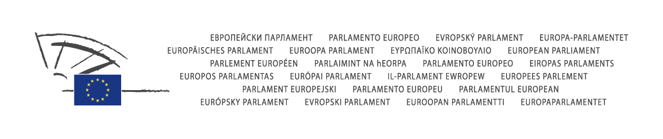

Committee on Development

Human Rights Slot on
Committee on Development

Human Rights Slot on

The International Criminal Court and International Justice

Monday, 15 September 2008, 16.00-17.00

European Parliament, Brussels
Room: ASP 3 G 3

Chair:
Josep Borrell Fontelles

Presenter:
Thijs Berman

Programme

16.00 Introduction by Thijs Berman

16.05 Keynote speech

Ms Fatou Bensouda, Deputy Prosecutor of the International Criminal Court:
State of Play in the Cases before the Court

16.20 Ms Alison Smith, No Peace without Justice: The Role of Civil Society in the Promotion of International Justice
Mr Herman von Hebel, Registrar of the Special Court for Sierra Leone: Current Challenges for the Special Court

16.30 Questions and Answers

17.00 Conclusions by Thijs Berman

The Members of the Subcommittee on Human Rights are associated with this Meeting.
Contacts

Secretariat | Telephone | e-mail
Marika LERCH | 32.2.283.27.85 | marika.lerch@europarl.europa.eu
Petra UHRMEISTER  Secretariat | 32.2.284.34.29 | petra.uhrmeister@europarl.europa.eu

Important notice for those wishing to attend the meeting
The hearing is open to the public. However, for security reasons, participants who do not
have a European Parliament access badge must obtain a pass in advance. Those wishing to
obtain such a pass should contact the secretariat (email: petra.uhrmeister@europarl.europa.eu) before
11 September 2008, 12.00)

